

**SG EMO-17304**

**4-Channel 1080P Cabinet Debugging Monitor**

Specification

**Ver 1**.**0**

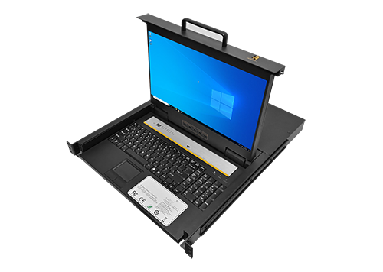

Physical Reference

**深圳市瑞众科技有限公司**

**SHENZHEN RUIZHONG TECHNOLOGY CO., LTD.**

**Product Description**

VMEET SG EMO-17304 4-way 1080P cabinet debugging display integrates LED display, ultra-thin keyboard, mouse touchpad, set in 1U height unit, the use of drawer installation method, completely solves the space shortage of standard keyboard, monitor, and mouse compared to saving 85% space. High-quality Class A 17.3 "LED (no highlights) display, built-in switch can directly manage 4 servers; Up to 128 servers can be managed.

# Main features

★ Support 4 HDMI signal inputs, a single group of control terminal management 4 servers, can cascade multiple devices, can manage up to 128 computers.

★ 17.3" LED screen, keyboard and mouse integration, single double slide body, only 1U rack space; 17.3 inches LED LCD display, high brightness, high definition, resolution up to 1920x1080@60Hz.

★ Effectively save room space, when the keyboard/trackpad is not needed, it can be pushed back into the rack, only the thin LED display is retained to facilitate the management to monitor the status of the server, and the guide rail is equipped with self-locking device.

★ Support hot swap - Add or remove servers at any time without turning off the power.

★ Provide automatic scanning mode and sustainable monitoring of the user's selected host.

★ Drawer type, USB HUB function can be realized through the front USB2.0 interface.

★ Easily switch between servers with hotkeys and panel keys.

★ Compatible with Dos/Windows series, UnixMac OS 8.6/9/10, SUN Solaris 8/9, Kirin System, UOS (unified operating system, UnionTech OS, Deepin, Puhua OS, Red Flag Linux, and other operating systems.

★ The LED display can be expanded to 135 degrees to provide a comfortable viewing Angle.

# Product Appearance

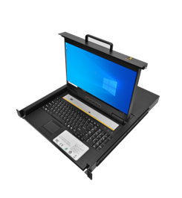

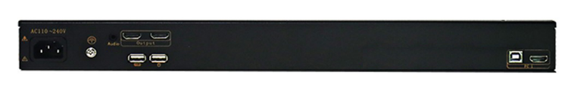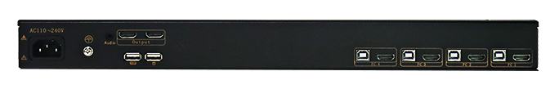

Interface display

Front view

# Product Connection Diagram

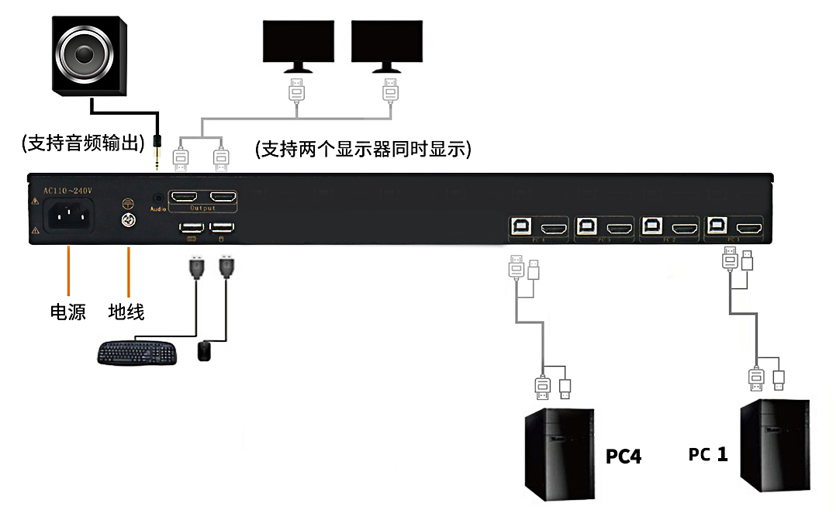

**Support audio output**

**Power Ground**

**supply wire**

**Supports two monitors to be displayed at the same time**

# Technical Specifications

|  |  |  |  |  |
| --- | --- | --- | --- | --- |
| Model： | | SG EMO-17304 | | |
| Accessories： | | Includes 2 mounting ears, 4 KVM cables (1.8 meters), optional 3-meter and 5-meter cables available | | |
| Computer Connection： | | 4 computers | | |
| Maximum Computer Connection： | | 32 computers | | |
| Connection Ports： | | HDMI interface (4*USB for keyboard and mouse) | | |
| Switching Scan Time： | | 1~255 seconds (adjustable via OSD) | | |
| Applicable Cabinet： | | 800-1040MM | | |
| Switching Method： | | Hotkey switching, button switching | | |
| LED Display： | | Size: 17.3" LED  Resolution: 1920*1080@60Hz  Brightness：300nits  Contrast Ratio：1000:1 |
| LED Display Control： | | Multi-language OSD adjustment for optimal performance |
| Keyboard /Mouse： | | 104-key mechanical silent keyboard, Touchpad |
| Voltage Input： | | A110V-240V  50Hz-60Hz Power Consumption: 35W |
| Material： | | High-strength anti-corrosion steel plate |
| Exterior Color： | | Insulated black paint |
| Dimensions  (L*W*H) ： | | 550mm (depth) * 481mm (width) * 43.8mm (height) |
| Gross Weight： | | 17.5KG |
| Storage Temperature： | | -30℃~70℃ |
| Operating Temperature： | | -10℃~60℃ |
| Humidity： | | 0%-80%/RH |

|  |
| --- |
|  |